

OUR MISSION IS STUDENT SUCCESS … ACADEMIC, ARTISTIC AND HUMANISTIC

45 Prince Street at University Rochester, New York 14607 (585) 242-7682

October 4, 2024

Dear Parents and Students:

The purpose of this mailing is to provide information to RCSD families about School of the Arts (SOTA) and our application/audition process. All students interested in attending SOTA must successfully complete an audition. Students may audition in one of six arts disciplines: Creative Writing, Dance, Drama, Music (Band, Choir, Strings, or Piano), Theatre Technology or Visual Arts. All students interested in auditioning for SOTA must submit a School of the Arts Application. The application is included in this mailing and can be mailed to School of the Arts, or completed online at [SOTAROCHESTER.ORG](http://www.sotarochester.org). **The deadline to submit your School of the Arts Application is December 20, 2024**. Once your application is received, you will be scheduled for an audition on one of the following days; **January 21, 22, or 23, 2025** from **5:00 PM to 8:00 PM**. Families will be notified of specific audition dates the week of January 6, 2025.

We encourage prospective SOTA students and their families to join us on **Thursday, November 14, 2024,** from 5 PM – 7 PM for our **SOTA School Selection Open House**. This event provides an opportunity to meet the SOTA staff, learn more about the audition process, and take a tour of our facility. Families will also have the opportunity to witness firsthand the dedication and talent of SOTA’s current students through a variety of performances and presentations.

Audition documents and informational videos explaining the audition process for each Arts department are also available on SOTA’s website - [SOTAROCHESTER.ORG](http://www.sotarochester.org) – under the “Apply to SOTA” link on the homepage. Additionally, we encourage prospective students and families to attend SOTA’s numerous evening Arts events, all of which are open to the public and many of which are free of charge. A 2024-2025 performance calendar is included in this mailing.

PLEASE NOTE: If you apply to School of the Arts, you must also complete the RCSD *Schools of Choice Application Process* identifying alternative school choices or placement preferences in the event that your child is not accepted to SOTA. More information about the Schools of Choice process will be forthcoming from the Office of Student Placement and Equity.

If you have questions about School of the Arts, please email us at [SOTAINFO@RCSDK12.ORG](mailto:sotainfo@rcsdk12.org). For more information about the secondary school selection process, please contact the *Office of Student Equity and Placement* at 262-8241. Thank you!

**Important Dates:**

* **November 14, 2024** – SOTA School Selection Open House -   
  SOTA Application Available
* **December 20, 2024** - Deadline for Completed SOTA Application
* **January 21-23, 2025** - SOTA Audition Dates

***Please Save the Dates Listed Above: your child will be scheduled to audition on ONE of these days.***

* **March 2025** - Deadline for Completed RCSD Schools of Choice Application
* **April 2025 –** SOTA Acceptance Letters Mailed

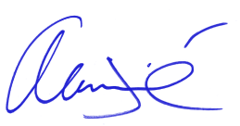

Alan A. Tirré  
*Principal   
School of the Arts*

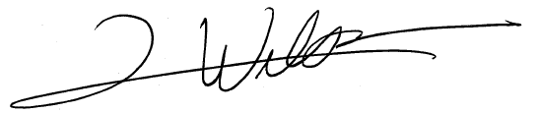

Luke Wilson  
*Assistant Principal  
School of the Arts*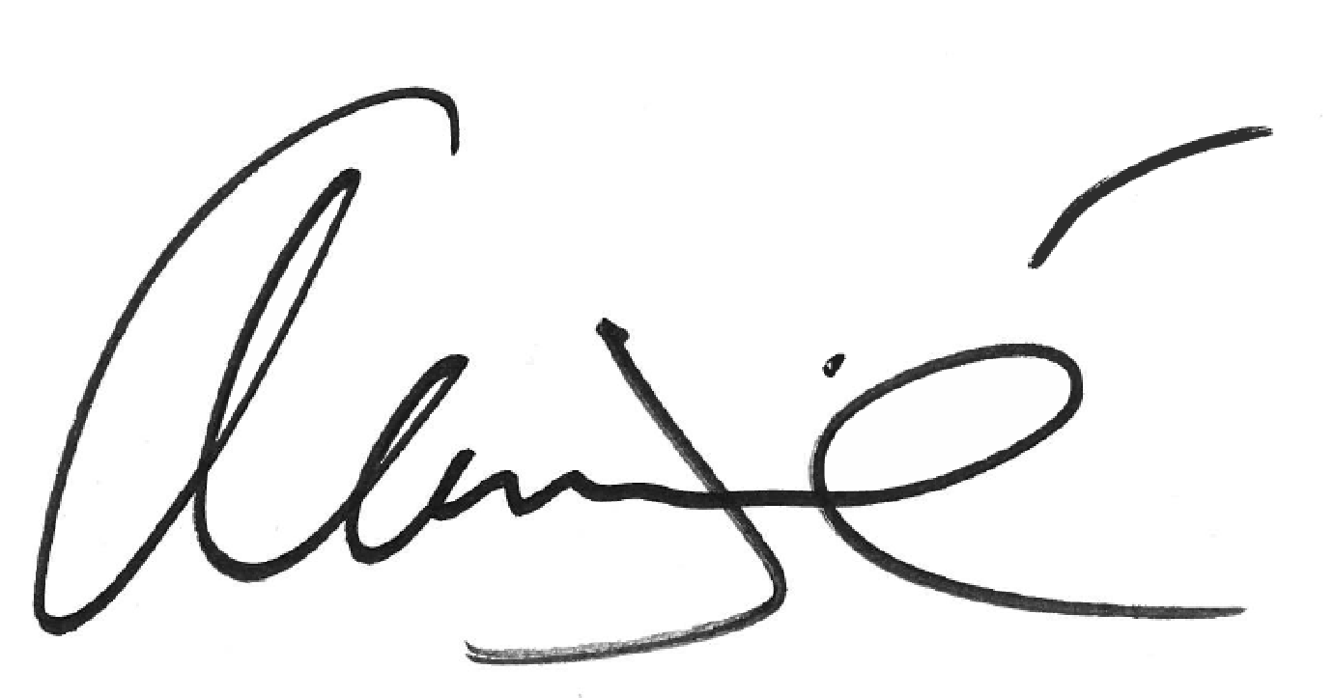

**School of the Arts Audition Process**

**AUDITION DATES: JANUARY 21-23, 2025 - 5:00 PM - 8:00 PM**

|  |
| --- |
| **• Be Available on Audition Dates.** Auditions will be scheduled by School of the Arts. Applicants cannot request specific dates and/or times.  **• Auditions CANNOT be Rescheduled for Any Reason.**  **• You Must Select ONE Arts Discipline in Which to Audition**. Applications will *not* be processed if you choose more than one art area. Do not call School of the Arts to schedule an audition. All applicants will receive a letter with an audition date.  **• Auditions Will Vary by Arts Discipline.** Students will present/perform their prepared audition materials for their teachers and may participate in a classroom setting specific to that art area. Every audition will be measured according to a standard rubric. Each student will receive a numerical score from 1-10, with 10 being the highest.  **All Students Are Required to Bring:**  1. **A Written Essay** (5-7 sentences long) explaining why you want to attend SOTA, and why you are auditioning in your chosen art.  2. **A Confidential Applicant Snapshot**from a previous or current teacher. *Confidential Applicant Snapshots* are online: SOTAROCHESTER.ORG.  3. Additional Audition Requirements by Arts Discipline as Listed Below. |

|  |
| --- |
| ***Additional Audition Requirements by Art Area*** |

***CREATIVE WRITING***

***Please Bring:***

• A full portfolio of your written work reflecting different genres and styles. Each portfolio should include a varied selection of poetry (rhymed and unrhymed), a varied selection of fiction (short stories, plays) and a variety of non-fiction work (essays, book reports, journalism, reviews, class projects that reflect research, etc.) Additionally, please include original drafts of work that has been revised.

• Pencil, pen (blue or black ink only). Paper will be provided.

***You MAY be Requested to:***

• Participate in a writing workshop.

***DANCE***

***Please Bring:***

• Dance attire (leotard, tights) or close-fitting athletic wear (no shorts – no bare legs).

• For safety, use dance shoes or bare feet.   
• A recording of music for the piece you  
 will perform. This can be on a phone, tablet, YouTube, or a CD

**SOTA Applicants Must Fill Out the SOTA Application, Successfully Complete an Arts Audition and Provide Proof of Residency Upon Acceptance.**

*~ Please visit* SOTAROCHESTER.ORG *for more details ~*

***DANCE*** *(continued)*

***You MAY be Requested to:***

• Present a short dance sequence (at least 30 seconds to 1 minute in length).

• Respond to teacher-directed combinations.

***DRAMA***

***Please Bring:***

• A brief (approximately 100 words) memorized monologue from either a play or book in the first person (do not use speeches or rhyming poems). Talk to your teacher, or visit [www.stagemilk.com/monologues-for-kids](http://www.stagemilk.com/monologues-for-kids), or [www.dramanotebook.com/monologues-kids-teenagers/](http://www.dramanotebook.com/monologues-kids-teenagers/) for ideas.

***You MAY be Requested to:***

• Do some improvisation.

• Do a short reading which will be provided for you at the audition.

• Perform a scene with a partner

• Demonstrate ability to convey stage presence, emotion, body movement and response to direction.

***INSTRUMENTAL MUSIC***

**Band and Strings**

***Please Bring:***

• Your instrument.

• One or two prepared selections.

• Sheet-music sample(s) or book(s) of music you are playing at this time.

***You MAY be Requested to:***

• Play three major scales from memory.

• Play at least one prepared piece.

• Demonstrate sight reading ability.

• If you are auditioning for drum set, you will be requested to play at least three of the following styles: Swing**,** Samba**,** Funk**,** Rock**,** Bossa Nova**,** Disco**,** Shuffle**,** Jazz**,** Waltz. You will also be expected to prepare the components for the standard percussion audition including: three scales of your choice, a prepared solo piece, and sight-reading.

***PIANO***

***Please Bring:***

• One or two prepared selections.

• Sheet music sample(s) or book(s) of music that you are playing at this time.

***You MAY be Requested to:***

• Play three scales with both hands from memory.

• Demonstrate sight reading ability.

• Play a simple arrangement of Beethoven’s   
 “Ode to Joy.”

• Play at least one additional prepared piece.

***VOCAL MUSIC***

***Please Bring:***

• A copy of the sheet music for your prepared song. An accompanist will be available to you.

***VOCAL MUSIC*** *(continued)*

***You MAY be Requested to:***

• Sing one major scale.

• Sing “America” aka: “My Country Tis of Thee.”

Diction is an important part of this segment.

• Sing one prepared song of your choice; an accompanist will be provided.

• Sight-sing a simple four-measure melody.

***THEATRE TECHNOLOGY***

***Please Bring Any Three of the Following:***

• A Drawing, Painting or Paper Mache project that you created at home or in your art class of which you are proud.

• Your ideas for a Dollhouse Ground Plan including a living room, kitchen, bedroom, etc.

• Something built from wood, like a box or birdhouse.

• A list of sets and props from an episode of your favorite TV show, movie, or cartoon.

• Your ideas or plans about how you would build a bookshelf.

• An example of Computer Art or Computer Drawing you created.

***You MAY be Requested to:***

• Do measuring activities with a standard ruler.

• Draw pictures based on moods / emotions / words; problem solve in a group activity; follow instructions to build a simple object.

• Work with basic hand tools.

• Learn to use a computer for drawing.

***VISUAL ARTS***

***Please Bring:***

• A #2 pencil and eraser.

• A sample observational drawing that you have done, in pencil, of an old shoe on a piece of 8.5” x 11” white paper. Be sure to look closely at the shoe and draw what you see. This will be left at the audition.

• A Portfolio of your original artwork that includes 6-8 samples of your best 2-dimensional and 3-dimensional (sculptures) artwork. You can also bring a sketchbook of drawings if you have one. You can include work that you have done at home and/or at school. Please make sure your portfolio includes: an observational drawing of an object such as a kitchen utensil or tool, an observational landscape drawing, an observational portrait drawing of someone. **Please do not include cartoons, anime, or superheroes in your portfolio.**

***You MAY be Requested to:***

• Show a portfolio of your original artwork. You will take the portfolio home with you after the audition.

• Respond to questions about your artwork and art processes during an interview.

|  |
| --- |
| Application for School of the Arts |

(Please Print Clearly)

|  |  |  |  |  |  |  |  |  |  |  |  |  |  |
| --- | --- | --- | --- | --- | --- | --- | --- | --- | --- | --- | --- | --- | --- |
| Student Identification Number: | | | | | | ____________________________________________________ | | | | | | | |
| (your RCSD Google ID Number) | | | | | | | | | | | | | |
| Student Name: | | | ________________________________________________________________ | | | | | | | | | | |
| Address: | ____________________________________________________________________ | | | | | | | | | | | | |
|  | House Number | | | | | | | Street | | | Apartment | | |
|  | ________________________________________________________________________________ | | | | | | | | | | | | |
|  | City | | | | | | | State | | | Zip Code | | |
| Telephone: | | ________________________________________ | | | | | | | Birthdate: | | | ________________________ | |
| Current School: | | | | _____________________________________________ | | | | | | Current Grade: | | | ___________ |
| Parent / Guardian Name: | | | | | __________________________________________________________________ | | | | | | | | |
| Parent / Guardian Email Address: | | | | | | | __________________________________________________________ | | | | | | |

Check the ONE area in which you will be auditioning:

□ Creative Writing □ Dance □ Drama □ Instrumental Music   
 (Only One Instrument)

□ Theatre Technology □ Visual Arts □ Vocal Music □ Piano

Waiting List: Any student not chosen through the selection process will be placed on a waiting list that will expire at the end of August 2024. In the event of placement through the waiting list, a letter of acceptance will be mailed to the student’s home.

Sibling Preference: Sibling preference will only be taken into consideration in the event of a tie. ***Sibling preference does not guarantee admission.***

□ My brother/sister currently attends School of the Arts*.*

Name: Sibling ID#: ______________  
 (Sibling’s Full Name)

|  |  |  |  |
| --- | --- | --- | --- |
| Parent/Guardian’s Signature: |  | Date: |  |

|  |  |
| --- | --- |
| Application Deadline: December 20, 2024 | |
| **Please Return Completed Application to:**  **Or** | **SCHOOL OF THE ARTS 45 Prince Street Rochester, NY 14607** |

**Apply Online: SOTAROCHESTER.ORG**

